Object Counting using Connected-Component Labeling
Introduction
This assignment focuses on counting densely packed small objects using digital image processing techniques. A photograph of coins was processed using grayscale conversion, thresholding, morphological operations, and connected-component labeling to segment and count the objects.
Original Image
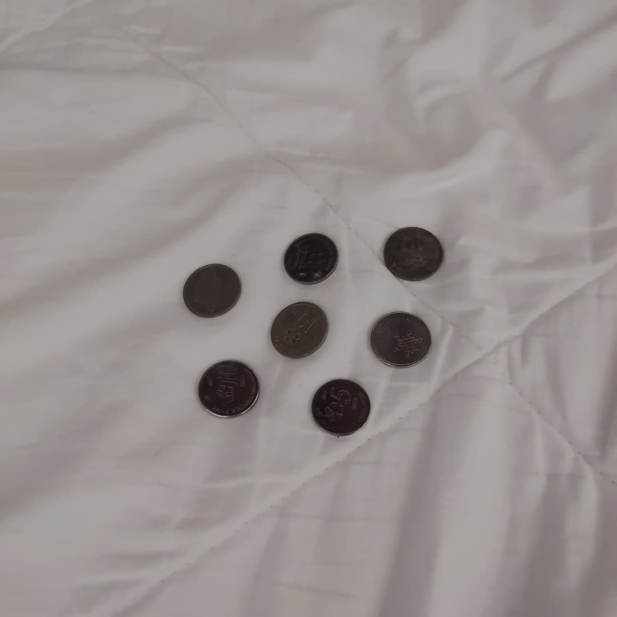
Figure 1: Original image of coins captured under natural lighting.
Methodology
Image Pre-processing
The input image was converted to grayscale to simplify intensity analysis. Gaussian smoothing was applied to reduce noise before thresholding.
Thresholding
Otsu’s thresholding method was used to automatically separate foreground objects from the background based on intensity distribution.
Morphological Operations
Morphological erosion followed by dilation was applied to remove noise and separate touching coins.
Object Counting
Connected-component labeling was used to identify and label connected regions of foreground pixels. Each labeled region corresponds to a single coin.
Implementation
The following Python code was used to implement the proposed approach using NumPy, PIL, SciPy, and Matplotlib.
import numpy as np
import matplotlib.pyplot as plt
from PIL import Image
from scipy import ndimage

#Load image
img = Image.open("C:\\Users\\USER\\Downloads\\coins.jpg")
img_gray = img.convert("L") # grayscale

gray = np.array(img_gray)

#Gaussian smoothing (noise reduction)
blur = ndimage.gaussian_filter(gray, sigma=1)

#Otsu thresholding (manual implementation)
hist, bins = np.histogram(blur.flatten(), 256, [0, 256])
hist = hist.astype(float)
hist /= hist.sum()

omega = np.cumsum(hist)
mu = np.cumsum(hist * np.arange(256))
mu_t = mu[-1]

sigma_b2 = (mu_t * omega - mu) ** 2 / (omega * (1 - omega) + 1e-12)
threshold = np.argmax(sigma_b2)

binary = np.zeros_like(blur)
binary[blur < threshold] = 1 # coins are darker → foreground

#Morphological operations
structure = np.ones((3, 3))

#Erosion then dilation (opening)
eroded = ndimage.binary_erosion(binary, structure=structure, iterations=2)
dilated = ndimage.binary_dilation(eroded, structure=structure, iterations=2)

#Connected component labeling
labeled_img, num_objects = ndimage.label(dilated)

print("Number of objects detected:", num_objects)

#Display results
plt.figure(figsize=(12,8 ))

plt.subplot(2, 3, 1)
plt.imshow(gray, cmap="gray")
plt.title("Grayscale")
plt.axis("off")

plt.subplot(2, 3, 2)
plt.imshow(blur, cmap="gray")
plt.title("Gaussian Blur")
plt.axis("off")

plt.subplot(2, 3, 3)
plt.imshow(binary, cmap="gray")
plt.title(f"Otsu Threshold (T={threshold})")
plt.axis("off")

plt.subplot(2, 3, 4)
plt.imshow(eroded, cmap="gray")
plt.title("After Erosion")
plt.axis("off")

plt.subplot(2, 3, 5)
plt.imshow(dilated, cmap="gray")
plt.title("After Dilation")
plt.axis("off")

plt.subplot(2, 3, 6)
plt.imshow(labeled_img, cmap="nipy_spectral")
plt.title("Connected Components")
plt.text(
20, 70,
f"Objects detected: {num_objects}",
color="yellow",
fontsize=16,
bbox=dict(facecolor="black", alpha=0.7)
)
plt.axis("off")

plt.tight_layout()
plt.show()
Result
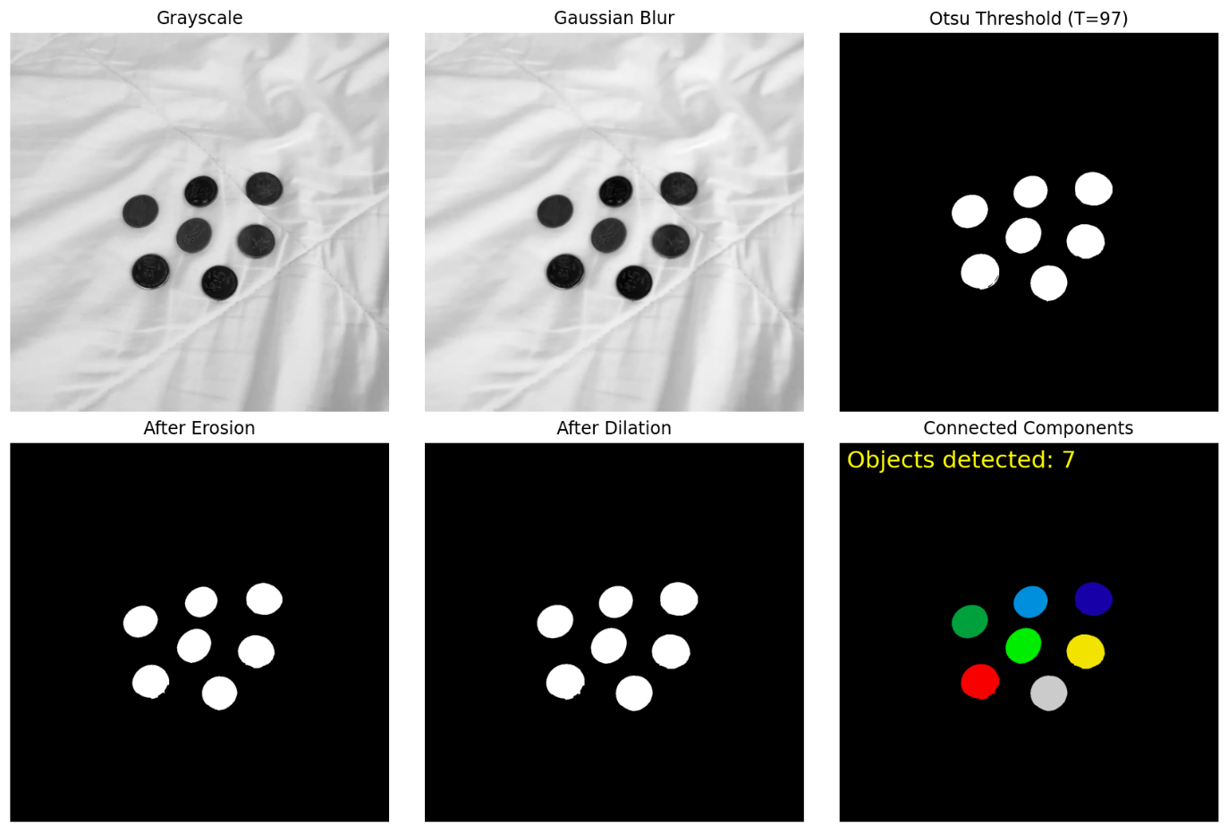
Figure 2: Image processing pipeline for object counting, including grayscale conversion, Gaussian smoothing, Otsu thresholding, morphological erosion and dilation, and the final connected-component labeling result.
Figure 2 shows the final detection result with the number of objects overlaid on the original image. A total of 7 coins were detected using connected-component labeling.
Discussion
The method successfully detected most coins in the image. However, objects that are very close to each other may still be counted as a single component. Adjusting morphological parameters can improve separation in such cases.
Conclusion
In conclusion, connected-component labeling combined with morphological processing is an effective approach for counting small objects in a binary image.

